**TRIBUTACAO DO CST 010**

**PRODUTO**

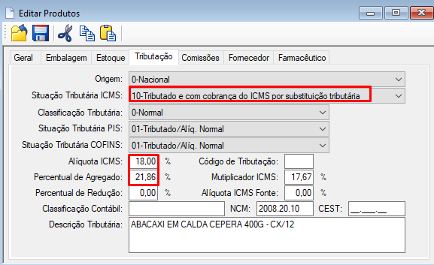

**PRE VENDA**

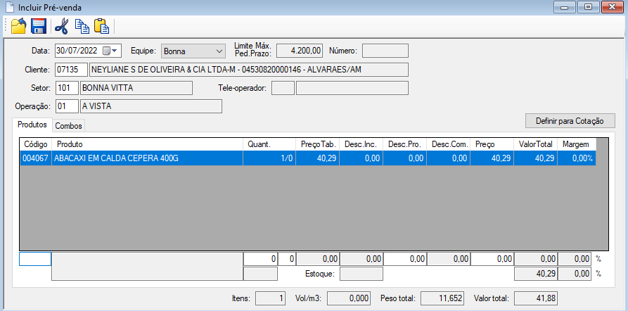

**(PRECO * MVA/100 + PRECO*ALIQUATA ICM/100) -(PRECO*ALIQUATA/100) +PRECO)**

**(40.29 * 21.86 / 100) + 40.29) * 18/100) - (40,29*18/100) +40,29)**

**((8.80 +40,29) *18/100)**

**49,09*18/100**

**8.837 - (7,252)+40,29)**

***1.585* + 40,29= 41,88**

**NF CLIENTES**

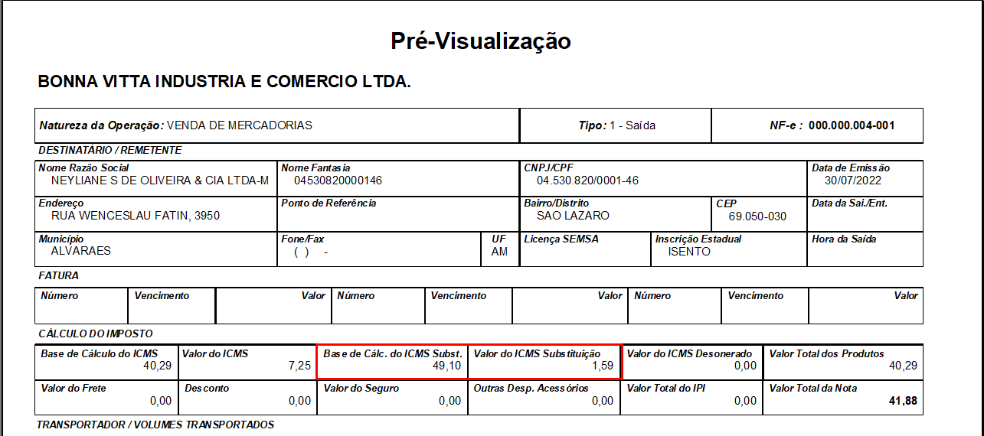

(1+(MVA/100)

(1+(21,86/100) = 1,2186

VALOR TOTAL DO PRODUTOS * 1,2186

40,29*1,2186= 49,10 *18 = 8,83 – 7.25 =1,59

ALIQUOTA ICMS